**Project Identification**

|  |  |
| --- | --- |
| **Project:** | Greenhills Christian Fellowship |
| **Prepared By:** | Phoenix Armand Ani (101336759)  Minh Nhat Vo (101224717)  Do Nam Huynh (101293009)  Jacob Solano (101348583) |
| **Document Version:** | Version 1.0 |
| **Published Date:** | September 26th, 2022 |

**Contributors**

*The following individuals contributed to this document.*

| **Name** | **Title** |
| --- | --- |
| Minh Nhat Vo | Contributor to the Sprint (has contributed to every piece of document) |
| Phoenix Armand Ani | Contributor to the Sprint (has contributed to every piece of document) |
| Do Nam Huynh | Contributor to the Sprint (has contributed to every piece of document) |
| Jacob Solano | Contributor to the Sprint (has contributed to every piece of document) |

**Distribution**

*This document is distributed to all the following people.*

| **Name** | **Title** |
| --- | --- |
| Minh Nhat Vo | GCF Team Member |
| Phoenix Armand Ani | GCF Team Member |
| Do Nam Huynh | GCF Team Member |
| Jacob Solano | GCF Team Member |
| Anajana Shah | Capstone Professor / Project Coordinator |

project summary, project vision

**Referenced Documents**

*This document refers to the following materials*

|  |  |  |  |  |
| --- | --- | --- | --- | --- |
| **Version number** | **Title** | **Author** | **Date** | **Source / Location** |
| 0.1 | Design and implementation of web-based church management system using PHP and MySQL | Agbemanbiese P.A | 2016 | http://ijeas.truescholar.org/articles/DESIGN%20AND%20IMPLEMENTATION%20new.pdf |
|  | St Jane Frances Church |  | 2022 | https://stjanefranceschurch.ca/ |
| 0.1 | Breeze Church Management Software - The World's Easiest ChMs |  | 2022 | https://www.breezechms.com |
| 0.1 | Church Home |  | 2022 | https://newlfietoronto.com |
| 0.1 | Church Management System Project |  | 2022 | https://www.campcodes.com/thesis/documentation/church-management-system-project-documentation/ |
|  | What is Church Management Software? Analysis of Features, Types, Benefits and Pricing | Allan Jay | January 29, 2019 | https://financesonline.com/church-management-software-analysis-features-types-benefits-pricing/ |

**Revision History**

|  |  |  |  |
| --- | --- | --- | --- |
| **Version Number** | **Revision Date** | **Summary of Changes** | **Modified by** |
| 1.0 |  |  |  |
|  |  |  |  |
|  |  |  |  |

*[Note: It is recommended that drafts be numbered 0.1 to 0.9, and that the first approved version be numbered 1.0. Thereafter, new version numbers will depend upon changes: 1.01, 1.1, etc for minor updates, 2.0, 3.0 etc for major changes.]*

**TABLE OF CONTENTS**

***1.*** ***BUSINESS CONTEXT DIAGRAM 3***

***2.*** ***REQUIREMENTS SCOPE STATEMENTS 4***

***3.*** ***HIGH LEVEL BUSINESS REQUIREMENTS (HLR) TRACEABILITY 4***

***4.*** ***HIGH LEVEL BUSINESS REQUIREMENTS SIGN-OFF 5***

1. **Business Context Diagram**

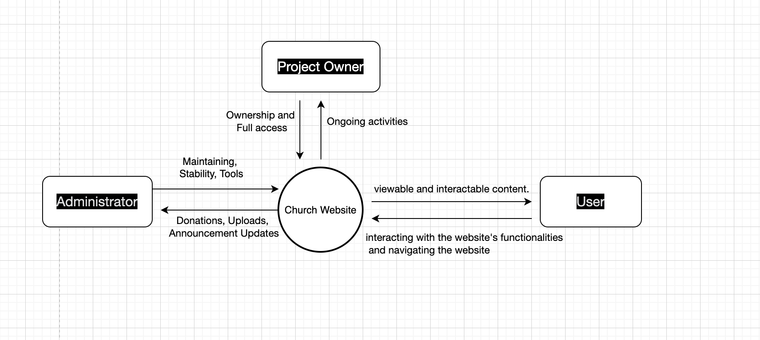

|  |  |
| --- | --- |
| **Requirement Scope Area** | **Description** |
| Wordpress | Building Website Application |

|  |  |
| --- | --- |
| **External Entity** | **Description** |
| Project Owner | The owner of the website |
| Administrator | Employee who has access to the website and make changes |
| User | A webpage visitor |
|  |  |
|  |  |

| **Information Flows** | **Description** |
| --- | --- |
| Donations | Users can donate on the website and the administrator will be the recipient and they are in charge of managing the funds. |
| Prayer Items | Users are able to post on the website their prayer items and the administrators are the recipients. They will pass this on to an official of the Church. |
| Announcements and Updates | The administrators will update the website and upload announcements for the users to view so that they will be aware of any changes that the church has made.. |
| Church Service Recordings | The administrators will upload the church recordings for the users to watch so that they would be able to catch up to the church’s teachings. |
|  |  |
|  |  |

1. **Requirements Scope Statements**

|  |  |  |
| --- | --- | --- |
| **HLR#** | **Description** | **Priority**  **(H, M, L)** |
|  | The team would discuss the layout and functionalities of the website with the stakeholders and project owner. | H |
|  | The team would start building the website based on the project owners requirements. | M |
|  |  |  |
|  |  |  |
|  |  |  |

1. **High Level Business Requirements Sign-Off**

*The undersigned acknowledge their agreement with the contents of Version <*x.x*> of the* High-Level *Requirements document for <Project Name>*.

*Following approval of this document, requirements changes will be governed by the project’s change management process, including impact analysis and appropriate reviews and approvals, under the general control of the Project Plan and according to company policy. Approved Change Request Documents, if present, will be attached to this Requirements Document as updates.*

|  |  |  |
| --- | --- | --- |
| **Name** | **Project Role and**  **Functional Area** | **Date Signed** |
| Minh Nhat Vo | GCF Team Member | 10-02-2022 |
| Phoenix Armand Ani | GCF Team Member | 10-02-2022 |
| Do Nam Huynh | GCF Team Member | 10-02-2022 |
| Jacob Solano | GCF Team Member | 10-02-2022 |
| Joshua Sinena | Stakeholder | 10-02-2022 |

*\* Note: physical signatures are not required. Email approvals are acceptable and should be appended to project documents.*